Capture The flag #2

Spencer wise

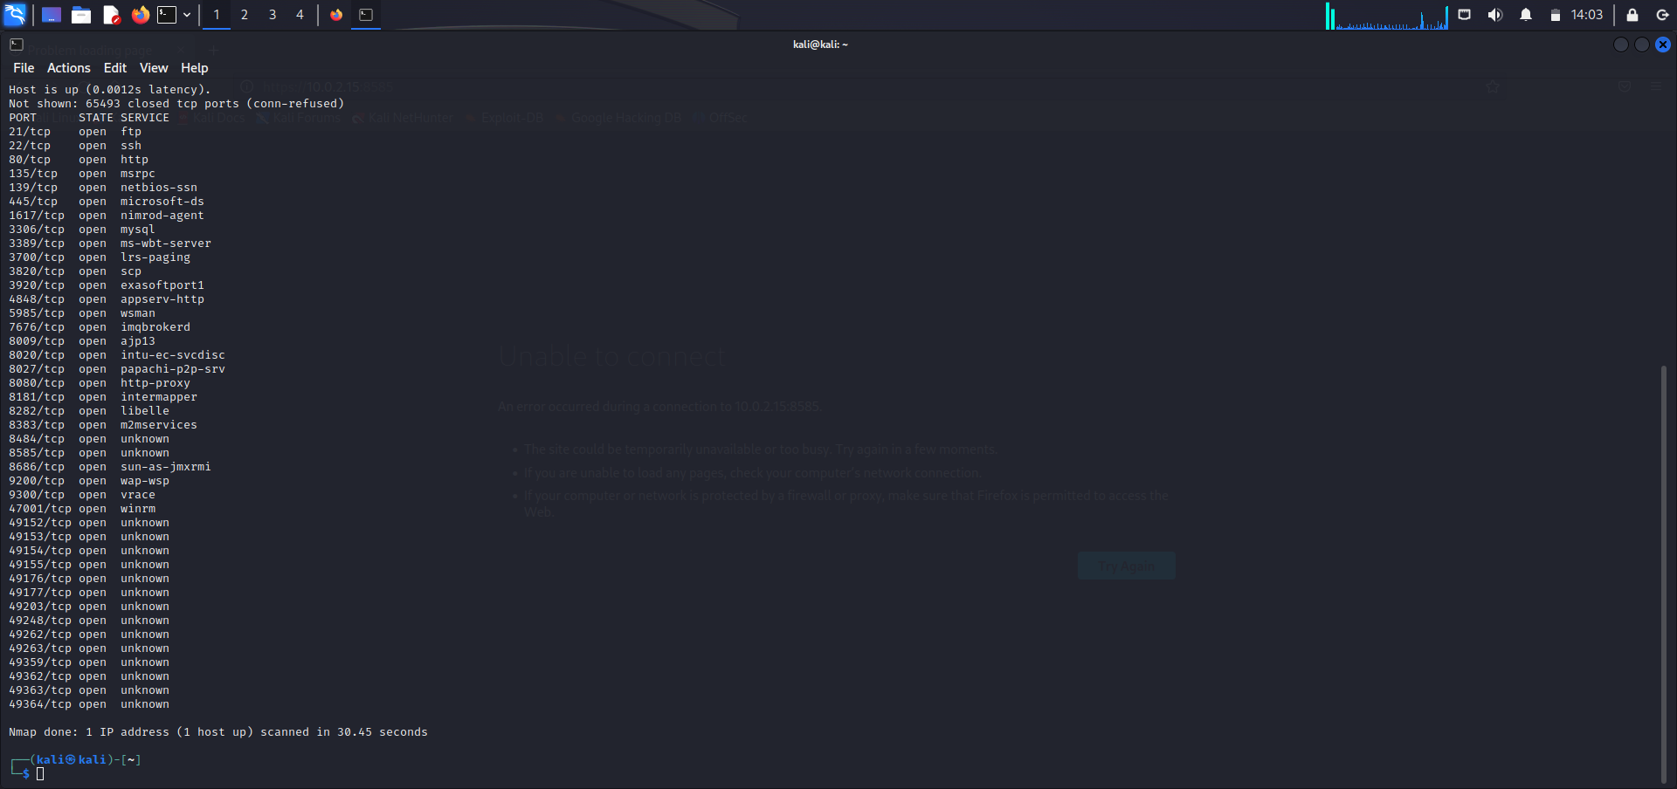

Did a nmap on the target IP. Saw that port 8585 is open.

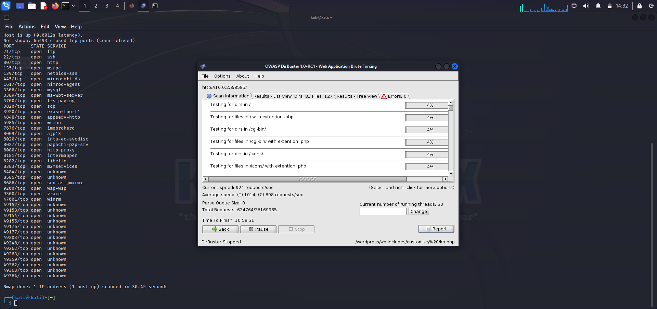

Using Dirbuster I targeted <http://10.0.2.8:8585> and selected a folder for it to be placed after the scan.

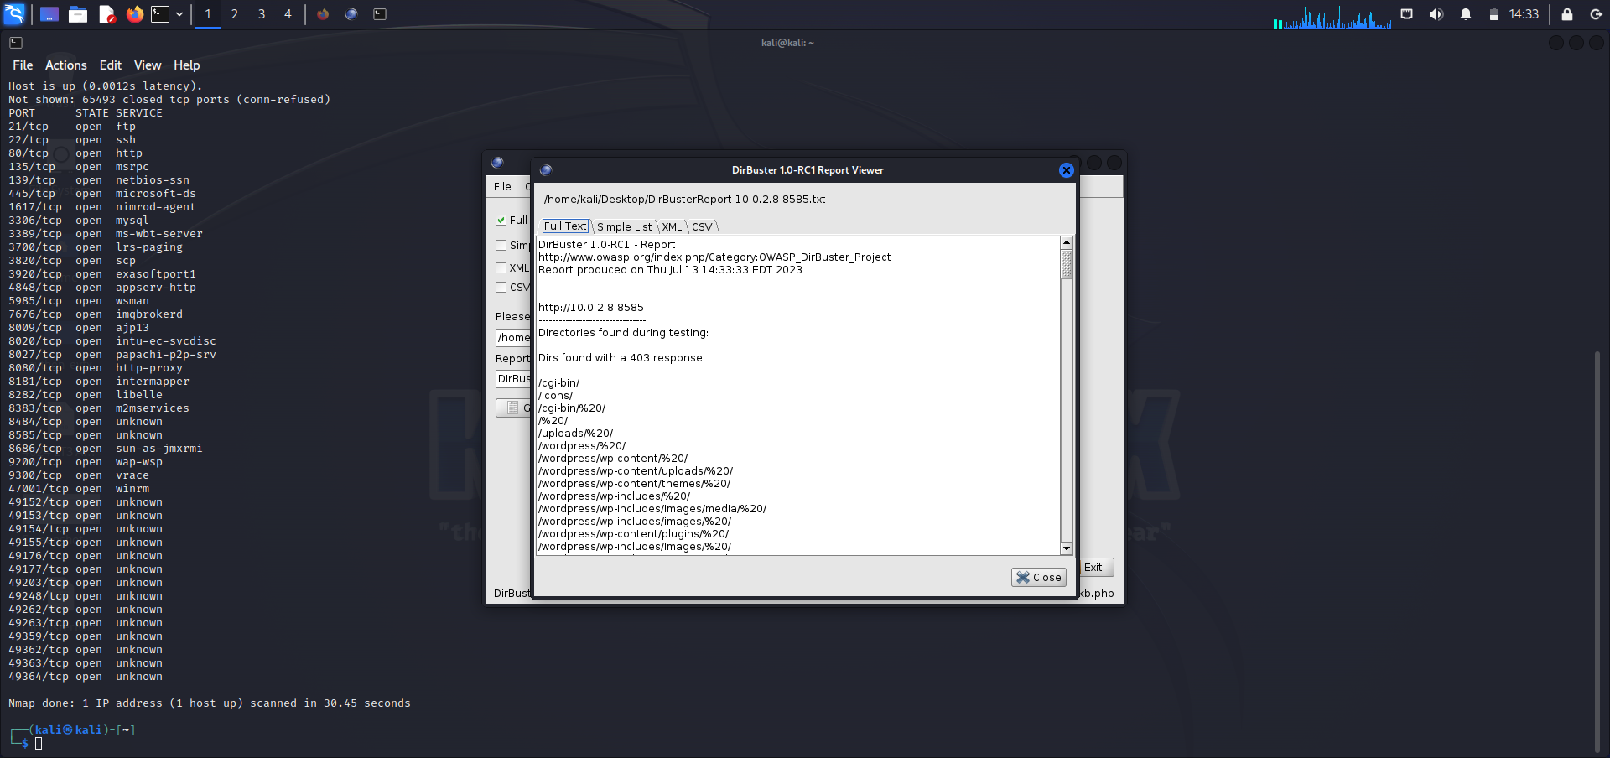

This is the generation of the files after I stopped the scan on Dirbuster.

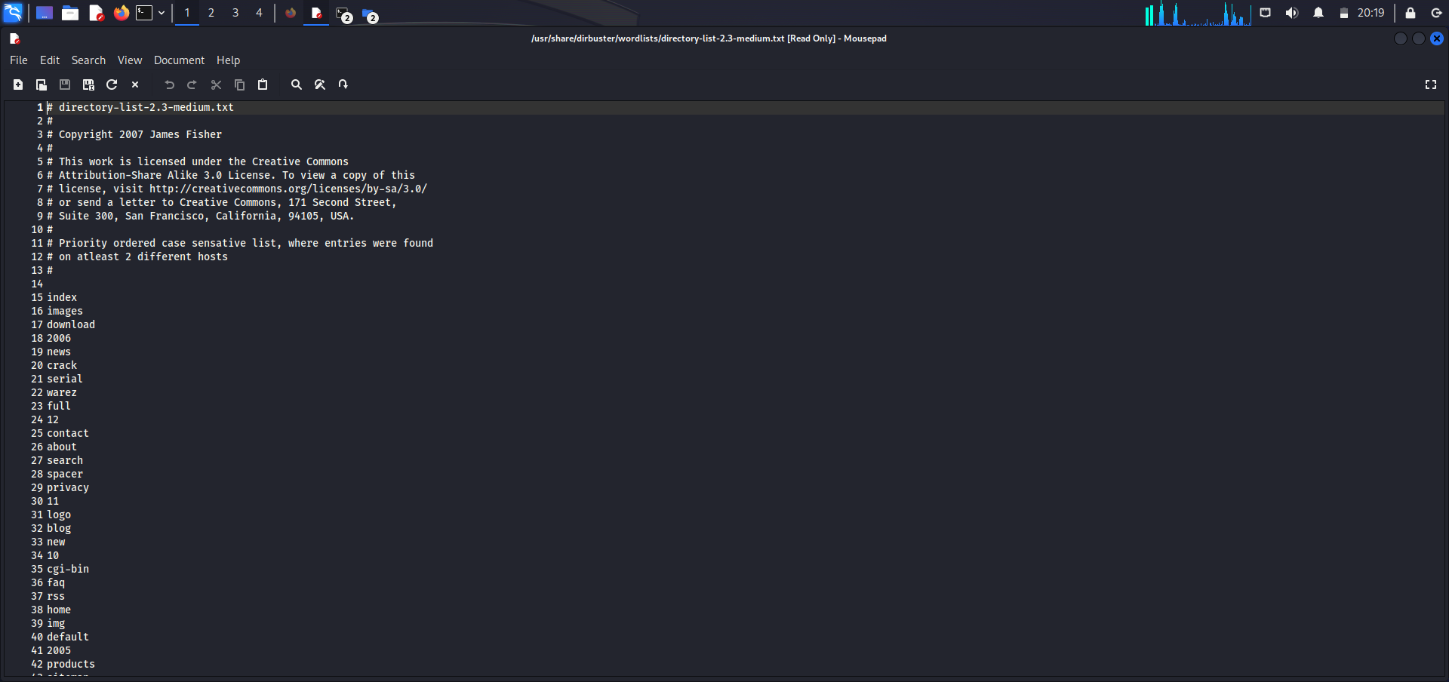

This is the Directory list of port 8585 through Dirbuster.

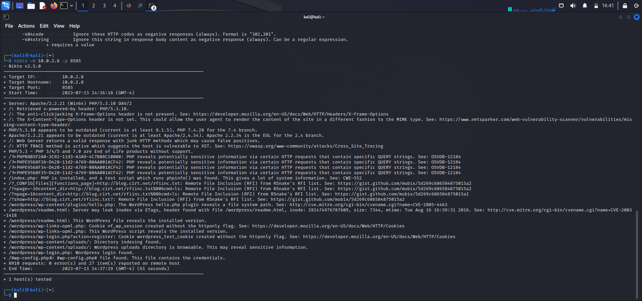

Running the Nikto scan shows a plethora of vulnerabilities.

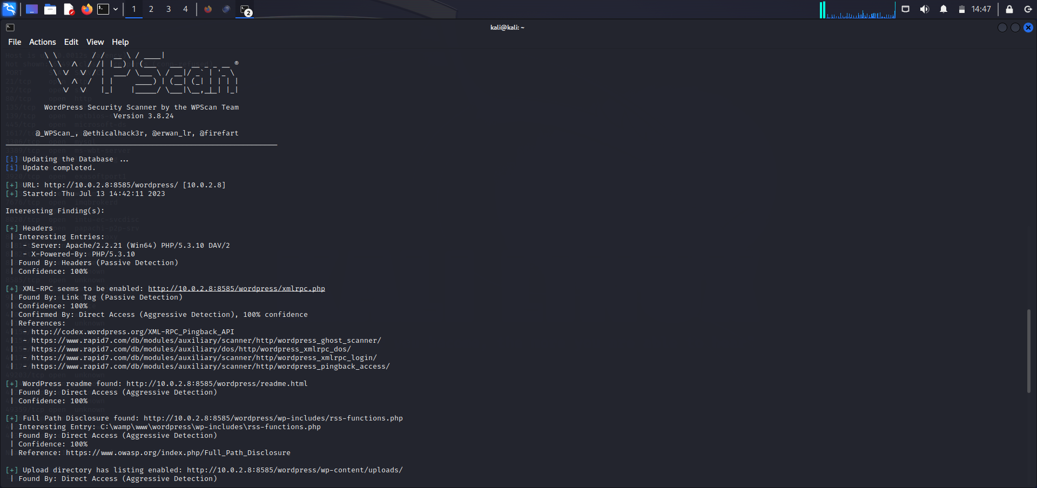

Ran a wpscan to find the flag and the scan produced a link to upload the directory.

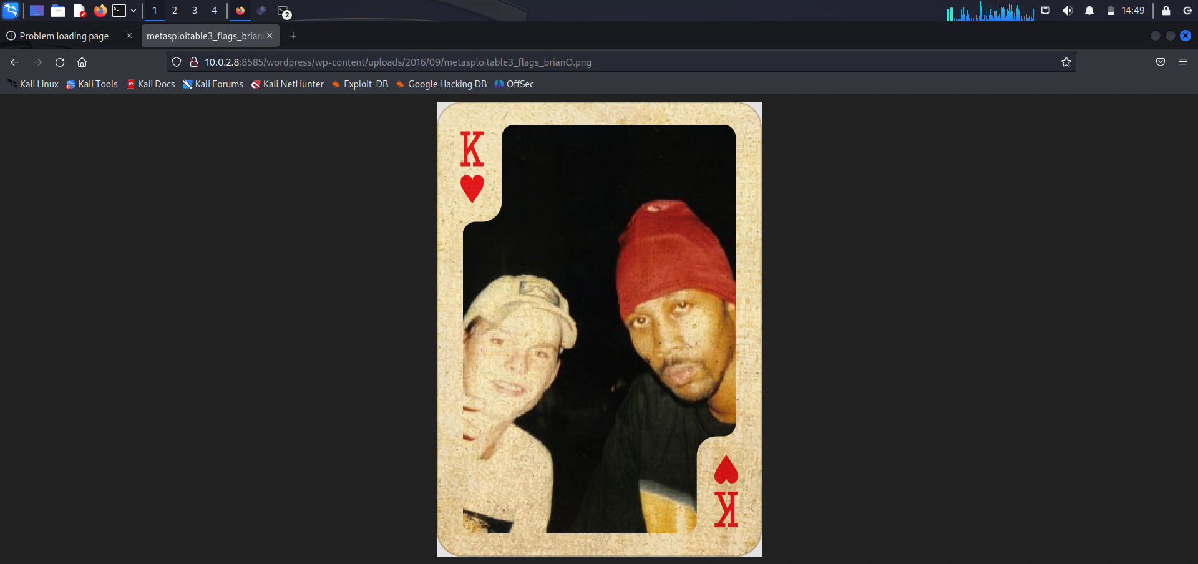

Flag found!!!